 | Autumn | Spring | Summer
Curriculum Bookshelf Books | 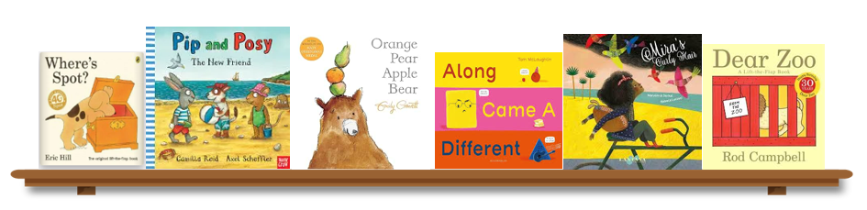 | 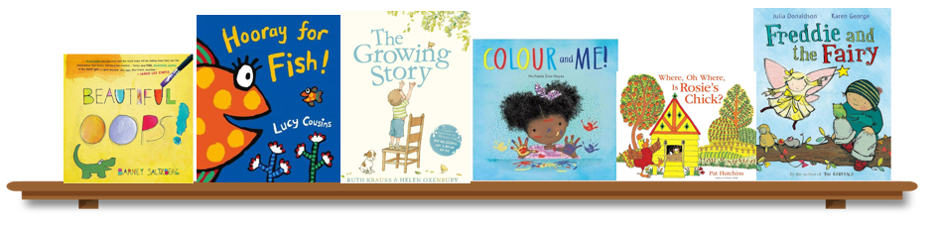 | 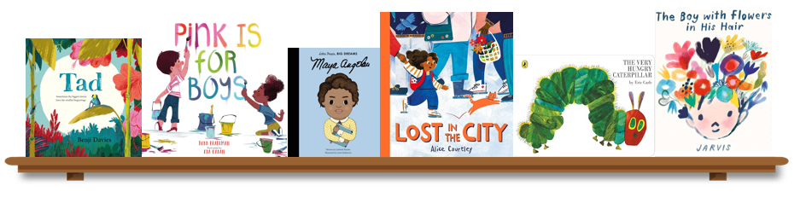
Personal, Social, Emotional, Development | To develop a sense of self and begin to see themselves as a valuable individual. Form relationships, understand empathy and emotions.  Communicate confidently, collaborate and solve conflicts.  Understand and make rules.
Physical Development | Gross motor skills, using large muscle movements.  Independence in self-care | Balancing and developing more complex movements  Fine motor skills  Understanding our needs | Fine motor skills  Understanding our bodies
Communication and Language | Practicing listening skills  Enjoying books and stories  Understanding instructions  Expressing our needs and thoughts. | Events and recall  Understanding questions and explaining  Telling stories | Focusing my attention  Initiating conversations  Building vocabulary and expressing opinions.
Literacy | Enjoying books and stories  Creating marks  Exploring Rhyme | Understanding rhyme and syllables  Giving meaning to marks  Understanding print.  Letter sound knowledge | Stories and early reading  Understanding words  Letter sound knowledge,  Blending and segmenting
Mathematics | Subitising  Reciting numbers, counting and order number names  Making arrangements with shapes  Explore position and space  Creating by combining shapes | Subitising  Take and Give 1,2,3  Number correspondence, counting backwards and forwards.  Exploring position and routes  Noticing and continuing repeated patterns | Subitising  Cardinality  Problem solving  Matching, sorting and comparing collections  Creating patterns
Understanding the World | I am unique  People in our community  Exploring how things work | Events in my life  Comparing past and present  Cause and effect  Understanding the world (different countries, cultures and traditions) | Animal and plant life cycles.  Changes  Using senses to explore the World
Expressive Art and Design | Colours and self portraits  Imaginative pretend play | Musical instruments and changing sounds  Natural art  Feelings represented by instruments | Exploring materials textures and tools  Experiences
The following curriculum overview may be subject to change. At Woodford Primary School we are constantly evolving our curriculum in response to the needs of learners and national strategies. For the most up-to-date information of what your child is learning please visit our year group page on the school website which is regularly updated throughout the year.
Pre-School Curriculum Overview

