Year 1 Curriculum Overview

 | Autumn |  | Spring |  | Summer
Bookshelf Texts | 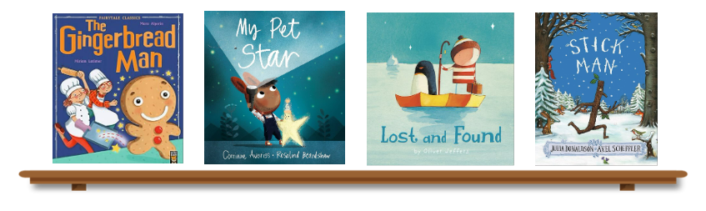 |  | 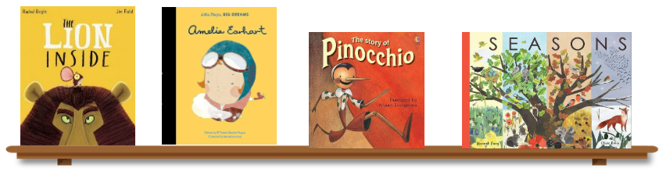 |  | 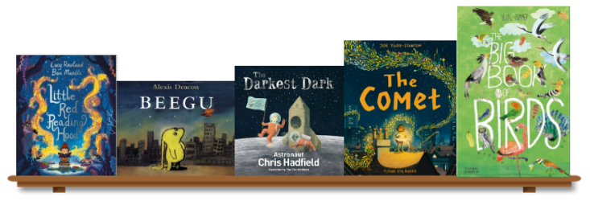
English | Shared Reading, Phonics & Handwriting  Writing: Labels, captions, and repeated phrasing, Character descriptions, Poetry, Narrative re-tell, Setting descriptions, Instructions |  | Shared Reading, Phonics & Handwriting  Writing: Character in a setting description, Narrative, Instructions, Non-chronological report, Story innovation, Diary |  | Shared Reading, Phonics & Handwriting  Writing: Narrative story, Non-chronological report, Recount, Poetry (performance), Diary
Maths | Number - Place Value  Number – Addition and Subtraction | Geometry – Shape | Number - Place Value  Number – Addition and Subtraction | Measurement – Length & height, weight & volume | Number - Place Value  Number – Multiplication and Division | Number – Fractions Geometry – Position & direction  Measurement – Money and time
Science | The Human Body  Materials  Seasonal Changes |  | Planting  Caring for the Planet  Animals  Seasonal Changes |  | Plants  Growing and Cooking  Planting  Seasonal Changes
Computing | Coding  E-safety |  | Online communication  Digital confidence |  | Programming  Computing and the wider world
History | Street Over Time |  | Flight Over Time |  | Female Monarchs
Geography | Maps, human and physical features – around our school |  | How do maps help us to understand where we live? |  | Why are settlements where they are?
D&T | Mechanisms – Sliders and Leavers |  | Food preparation – Preparing fruit and veg |  | Structures – Free standing structures
Art | Drawing and Collage |  | Sculpture - Clay |  | Drawing and Painting
RE | Living - What does it mean to belong to a faith/non-faith community? |  | Believing – What is Christian and what do they believe? |  | Expressing – what makes some places sacred?
PE | Fundamental Skills/Gymnastics – Balancing and Spinning  Invasion Games/Target Games |  | Net and Wall Skills/Dance (animals)  Striking and Fielding/Gymnastics (rolling and Balancing) |  | Athletics/Dance (under the Sea)  Object Manipulation/Yoga
Music | Pulse, Rhythm and Pitch  Reggae and Hip Hop |  | Different styles of Music  Bossa Nova Latin |  | Imagination  Reflect, Rewind and Replay
PSHE | This is Me!  VIPs |  | Dream Big  Healthy Body Healthy Mind |  | Our world  Growing and Changing
The following curriculum overview may be subject to change. At Woodford Primary School we are constantly evolving our curriculum in response to the needs of learners and national strategies. For the most up-to-date information of what your child is learning please visit our year group page on the school website which is regularly updated throughout the year.

