Year 3 Curriculum Overview

 | Autumn |  | Spring |  | Summer
Bookshelf Texts | 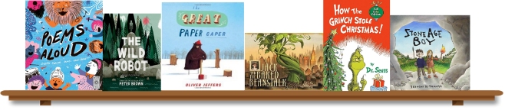 |  | 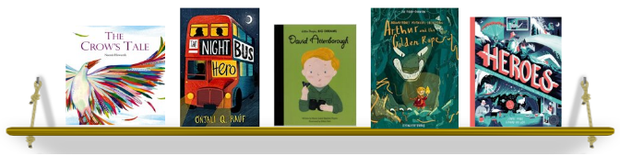 |  | 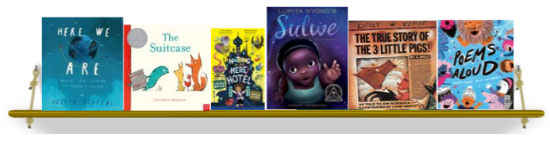
English | Shared Reading, Spelling & Handwriting  Writing to entertain: Character descriptions, Poetry(simile, metaphor), Narrative re-tell  Writing to inform: Non-Chronological Report, Instructions  Writing to persuade: Balanced argument |  | Shared Reading, Spelling & Handwriting  Writing to entertain: Character in a setting descriptions, diary  Writing to inform: Letter, Recount, Non-Chronological Report  Writing to persuade: Leaflet |  | Shared Reading, Spelling & Handwriting  Writing to entertain: Setting description, Narrative  Writing to inform: Non-Chronological Report, Book Review  Writing to persuade: Letter
Maths | Place Value  Addition and Subtraction | Addition and Subtraction  Multiplication and Division | Money  Multiplication and Division | Length and height  Mass, Capacity and temperature | Fractions  Time | Statistics  Position and direction
Science | Skeletons, Movement  Nutrition and diet | Food waste  Rocks | Fossils  Soils | Light | Plants A | Forces  Magnets  Plants B
Computing | Computing systems- connecting computers | Creating media- stop-frame-animation | Programming A- sequencing sounds | Data and information- branching databases | Creating media- desktop publishing | Programming B- events and actions in programs
History | How did Britain change during prehistory? |  | Why were the Ancient Egyptians so GREAT?
Geography | What are rivers and what do they provide us? |  | What can we learn from different maps? |  | What does data tell us about Europe?
Design Technology | Structures: Gift boxes |  | Textiles- 2D shape to 3D product (purses/ wallets) |  | Food Preparation: Healthy and varied diet (wraps)
Art | Hokusai- Drawing and painting |  | Pablo Picasso- Drawing and collage |  | Philip Treacy- Sculpture
RE | Believing: What do different people believe about God? |  | Expressing: How do family life and festivals show what matters to Jewish people? |  | Living: What does it mean to be a Hindu in Britain today?
PE | Lacrosse  Dance | Tag Rugby  Football | Netball  Gymnastics: Linking movements together | Health Related Fitness  Dance: Egyptians | Handball  Gymnastics: Receiving body weight | Rounders  Athletics
Music | Play in a class ensemble using tuned and untuned percussion | Recognise all four families of the orchestra | Listen to a selection of different and live music | Use rhythm flash cards and graphic scores | Improvise using al known rhythm tags | Play in class ensemble developing ability to play a tuned instrument
PSHD | This is Me! | VIPs | Dream Big | Growing and Changing | Healthy Body, Healthy Mind | Our World
The following curriculum overview may be subject to change. At Woodford Primary School we are constantly evolving our curriculum in response to the needs of learners and national strategies. For the most up-to-date information of what your child is learning please visit our year group page on the school website which is regularly updated throughout the year.

